**DAILY ONLINE ACTIVITIES SUMMARY**

|  |  |  |  |  |  |  |  |
| --- | --- | --- | --- | --- | --- | --- | --- |
| **Date:** | 06/06/2020 | | | | **Name:** | CHETHAN CK | |
| **Sem & Sec** | 4th SEM ‘A’ SEC | | | | **USN:** | 4AL18CS017 | |
| **Online Test Summary** | | | | | | | |
| **Subject** | | Data Communication(18CS46) | | | | | |
| **Max. Marks** | | 30 | | **Score** | | 28 | |
| **Certification Course Summary** | | | | | | | |
| **Course** | Complete Python Bootcamp: Go from zero to hero in Python 3 | | | | | | |
| **Certificate Provider** | | | Udemy | **Duration** | | | 2 Hours |
| **Coding Challenges** | | | | | | | |
| **Problem Statement:**1. Write a Java Program to find the duplicate characters in a string.  2. Write a program in C to rotate an array by N positions. | | | | | | | |
| **Status:** Completed | | | | | | | |
| **Uploaded the report in Github** | | | | YES | | | |
| **If yes Repository name** | | | | <https://github.com/alvas-education>-foundation/chethan_c_k | | | |
| **Uploaded the report in slack** | | | | YES | | | |

**Online Test Details:**

The online test was from module 5 which was about Wired LANs Ethernet, Wireless LANs, Other wireless Networks. There were 30 questions of 1 mark each which lasted for 45 minutes. The questions were easy. I scored 28 out of 30.

**Snapshot**:

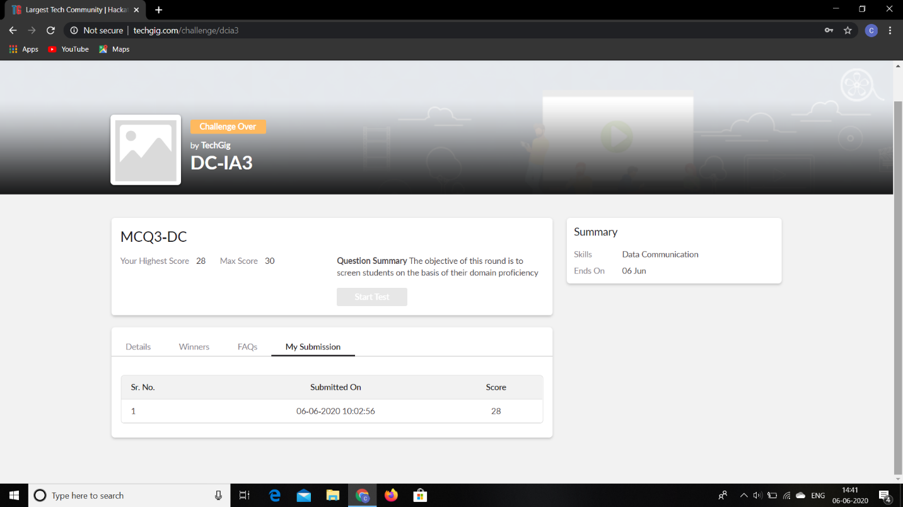

**Certification Course Details:**

**Name of the course**: Complete Python Bootcamp: Go from zero to hero in Python 3

**Certificate Provider**: Udemy

The entire session was about the List of Possible Widgets.

**Snapshot:**

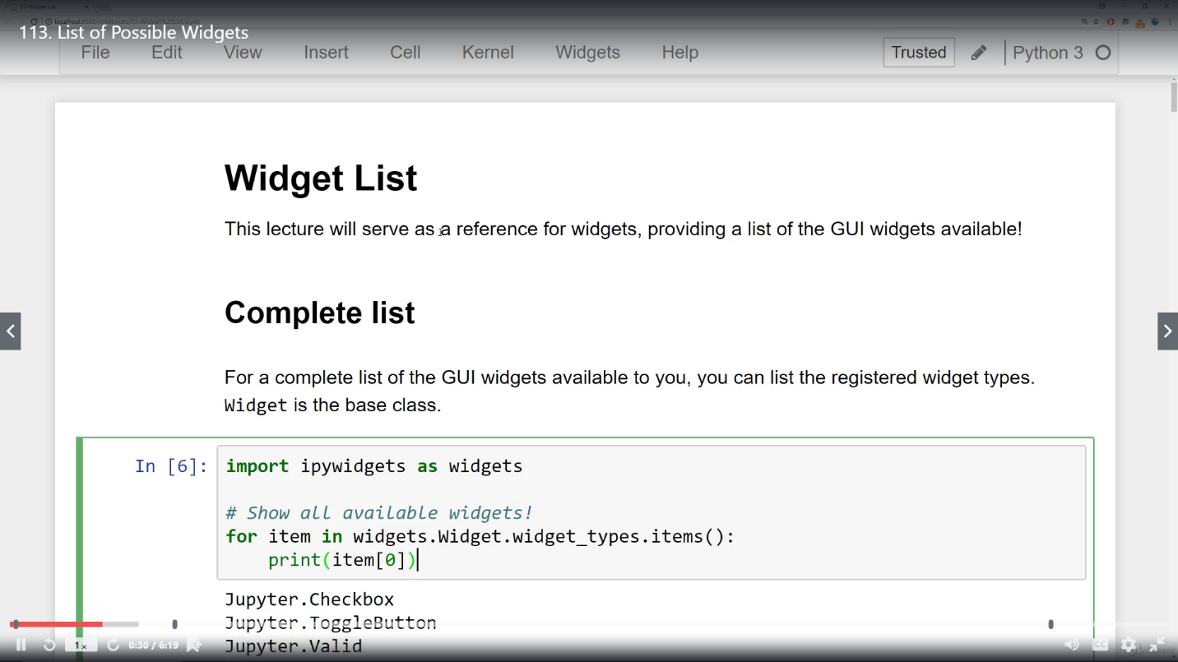

**Online Coding Details:**

Problem 1: Write a Java Program to find the duplicate characters in a string.

**Snapshot:**

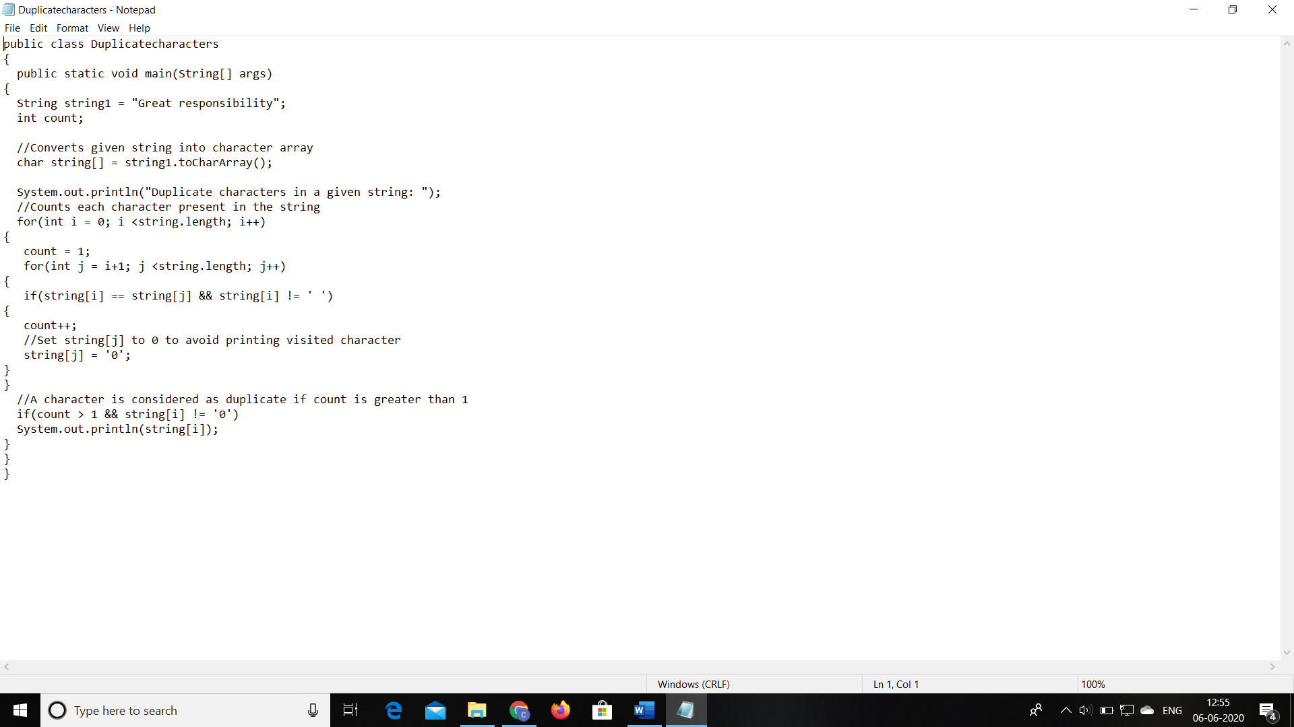

Problem 2: Write a program in C to rotate an array by N positions.

**Snapshot:**

